Chapter 6, Problem 33.

Obtain the Thevenin equivalent at the terminals, a-b, of the circuit shown in Fig. 6.65. Please note that Thèvenin equivalent circuits do not generally exist for circuits involving capacitors and resistors. This is a special case where the Thevenin equivalent circuit does exist.

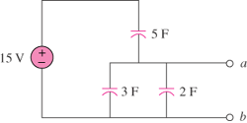
30 V

Figure 6.65
For Prob. 6.33.

